**VISVESVARAYA TECHNOLOGICAL UNIVERSITY**

BELAGAVI, KARNATAKA-590014

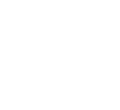

**Mini Project Report**

on

**“THE BLOG ZONE”**

Submitted by

**Ms. Jasnitha Joy 4DM21CS021**

**Ms. Minal Fathima P 4DM21CS026**

**UNDER THE GUIDANCE OF**

**Mr. Manjunath Raikar**

Assistant Professor,

Department of Computer Science & Engineering

In partial fulfillment for the award of the degree of

**BACHELOR OF ENGINEERING**

In

**COMPUTER SCIENCE AND ENGINEERING**

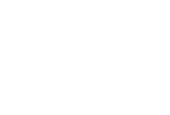

**YENEPOYA INSTITUTE OF TECHNOLOGY**

**N.H.13, THODAR, MOODBIDRI-574225, MANGALORE , D.K.**

**2023-2024**

**YENEPOYA INSTITUTE OF TECHNOLOGY**

N.H.13, Thodar, Vidyanagar, Moodbidri, Mangalore, Karnataka – 574225

**(Affiliated to Visvesvaraya Technological University, Belagavi)**

**DEPARTMENT OF COMPUTER SCIENCE AND ENGINEERING**



**CERTIFICATE**

Certified that the mini-project work entitled **“THE BLOG ZONE”** carried out by **Ms. Jasnitha Joy,** 4DM21CS021**, Ms. Minal Fathima P,** 4DM21CS026, are bonafide students of **Yenepoya Institute of Technology** in partial fulfillment for the award of **Bachelor of Engineering** in **Computer Science & Engineering** of Visvesvaraya Technological University, Belagavi during the year **2023-2024.** It is certified that all corrections/suggestions during the mini project has been incorporated in the report. The mini project report has been approved as it satisfies the academic requirements in respect of Mini Project work prescribed for the said degree.

____________________ ___________________

Signature of the Guide       Signature of the HOD

**Mr. Manjunath Raikar Prof Pandu Naik**

Name of the Evaluators Signature with date

1. ________________ 1. ________________  
   2. ________________ 2. ________________
2. ________________ 3. _________________

**DECLARATION**

We hereby declare that the project report entitled "The Blog Zone" submitted by us for the partial fulfillment of the requirements for the degree of computer science and engineering at Yenepoya Institute of Technology is our original work and has not been submitted earlier to any other institution or university for any degree or diploma.

We have acknowledged all sources of information and references used in the project report. We have also adhered to the ethical standards expected in academic work.

Jasnitha Joy

Minal Fathima P

**ACKNOWLEDGEMENT**

The successful completion of any work would be incomplete without a mention of the people who made it possible, whose constant guidance and encouragement served as a beacon light and crowned our efforts with success. We owe our gratitude to many people who helped and supported us during our Mini Project **‘The Blog Zone’**

Our deepest thanks to our guide **Prof. Manjunath Raikar**, Assistant Professor, Dept. of CSE, Yenepoya Institute of Technology for his constant support, encouragement and providing us with the necessary advices and help. We are highly indebted to him for taking keen interest in our work, monitoring and providing guidance throughout the completion of our work.

We also thank our project coordinator **Dr. Athokpam Bikramjit Singh.**, Professor, Dept. of CSE, Yenepoya Institute of Technology for his constant encouragement and support extended throughout.

We express our sincere gratitude to **Prof. Pandu Naik.,** Assistant Professor and Head, Dept. of CSE, Yenepoya Institute of Technology for his invaluable support and guidance.

We sincerely thank **Dr. R. G. D’Souza**, Principal, Yenepoya Institute of Technology for his constant support and providing us with all the facilities that were required.

Finally, yet importantly, we express our heartfelt thanks to our family & friends for their wishes, encouragement and providing me moral strength for the successful project presentation.

Jasnitha Joy

Minal Fathima P

**ABSTRACT**

The Blog Zone is an interactive platform designed for avid readers and writers. Users can explore a diverse range of blogs categorized by interest, ensuring tailored reading experiences. Empowering creativity, The Blog Zone allows users to create their own blogs, seamlessly edit them, and delete entries as needed. The intuitive interface simplifies content management, making it accessible for users of all skill levels. Whether sharing personal insights or engaging with community posts, The Blog Zone fosters a dynamic environment for expression and discovery. Join The Blog Zone to read, create, and manage blogs effortlessly.

**TABLE OF CONTENTS**

1. Synopsis1

2. Preamble2

3. Introduction3

4. Software Requirements Specification4

4.1 Software Requirements4

4.2 Hardware Requirements4

5. System Analysis and Design 5

5.1 System Analysis5

5.1.1 Problem Definition5

5.1.2 Objectives5

5.1.3 Feasibility Study5

5.1.4 System Requirements5

5.1.5 Use Case Analysis5

5.2 System Design6

6. Implementation 7

6.1 Development Environment Setup7

6.1.1 Tools and Software7

6.1.2 Database Configuration7

6.2 Frontend Development7

6.2.1 HTML/CSS/JavaScript7

6.2.2 Templates7

6..3 Backend Development7

6.3.1 Django Models7

6.3.2 Views and Controllers7

6.3.3 Forms and Validation7

6.4 User Authentication8

6.5 Blog Management8

6.5.1 Creating Blogs8

6.5.2 Editing Blogs8

6.5.3 Deleting Blogs8

6.6 Categorization8

6.7 Testing8

6.8 Deployment8

6.8.1 Local Deployment8

6.9 Pseudo Code9

7. Testing 10

7.1 Unit Testing10

7.1.1 Models10

7.1.2 Views10

7.1.3 Forms10

7.2 Integration Testing10

7.2.1 User Authentication10

7.2.2 Blog Management10

7.3 System Testing10

7.3.1 End-To-End Testing10

7.3.2 Performance Testing10

8. Conclusion 11

9. Future Enhancement 12

10. References 13

11. Appendix 14

11.1 Snapshots14

**LIST OF FIGURES**

5.1 Flow Chart of Working System7

11.1 Home Page14

11.2 Main Page14

11.3 Read Blog Page14

11.4 Blog Category Page14

11.5 Blog List Page15

11.6 Edit Blog Page15

11.7 Create Blog Page15

# 1. SYNOPSIS

# The Blog Zone is a dynamic and user-friendly blogging platform designed to cater to both readers and writers. It enables users to explore a wide range of blogs categorized by interest, ensuring a tailored reading experience. Users can create their own blogs, seamlessly edit them, and delete entries as needed. Key features include secure user registration and login, a personalized dashboard, and a responsive design for optimal use across browsers. Built with HTML, CSS, JavaScript for the frontend, Django (Python) for the backend, and SQLite3 for the database, The Blog Zone ensures a seamless and engaging experience. The development plan includes phases of planning, frontend and backend development, testing, deployment, and ongoing maintenance. The Blog Zone aims to foster a vibrant community of readers and writers, making it a go-to destination for sharing and discovering a variety of blogs.

# 2. PREAMBLE

The Blog Zone is conceptualized as a comprehensive platform designed to bridge the gap between readers and writers in the digital age. In an era where content consumption and creation are at their peak, The Blog Zone offers an intuitive and efficient space for users to explore and manage blogs. This project embodies the principles of accessibility, user-centric design, and community building. By leveraging modern web technologies and a robust backend framework, The Blog Zone ensures a seamless experience for users across various devices.

The platform's core functionalities are meticulously crafted to meet the diverse needs of its user base. Readers can effortlessly navigate through a plethora of categorized blogs, while writers are empowered with tools to create, edit, and manage their content. The emphasis on a responsive and interactive user interface highlights our commitment to providing a superior user experience.

Security and data integrity are paramount, with user authentication and content management handled securely within the Django framework, and SQLite3 serving as the reliable backend database. This project not only aims to facilitate personal expression and knowledge sharing but also aspires to cultivate a thriving community of bloggers and readers. The Blog Zone stands as a testament to the potential of collaborative digital spaces, fostering creativity and connection in the modern world.

# 3. INTRODUCTION

In today's digital era, blogging has become a powerful medium for individuals to share their thoughts, ideas, and experiences with a global audience. The Blog Zone is conceived as an innovative platform that brings together both readers and writers, fostering a dynamic and interactive community. This project aims to create an accessible and user-friendly environment where users can effortlessly read blogs based on their interests, and writers can easily create, edit, and manage their content.

The Blog Zone addresses the growing need for a comprehensive blogging platform that not only categorizes content for easy navigation but also provides robust tools for content creation and management. Users can register and log in securely, access a personalized dashboard, and utilize a rich text editor for crafting their blogs. The platform's design ensures a seamless experience across various devices, enhancing user engagement and satisfaction.

Built with modern web technologies, including HTML, CSS, and JavaScript for the frontend, and Django (Python) for the backend, The Blog Zone leverages SQLite3 as its database to ensure efficient data management and storage.

The Blog Zone aspires to be more than just a blogging platform; it aims to be a vibrant community where users can share knowledge, express creativity, and connect with like-minded individuals. By prioritizing user experience and content management, The Blog Zone is poised to become a go-to destination for bloggers and readers alike.

# 4. SOFTWARE REQUIREMENTS SPECIFICATION

# 4.1 SOFTWARE REQUIREMENTS

* **Operating System:** 
  + Windows 10 or later
* **Development Environment:**
  + Visual Studio Code
* **Languages and Frameworks:** 
  + HTML, CSS, JavaScript for frontend development
  + Python (Django framework) for backend development
* **Database:** 
  + SQLite3
* **Browser Compatibility:**
  + Google Chrome
  + Mozilla Firefox
  + Microsoft Edge

# 4.2 HARDWARE REQUIREMENTS

# Development Machine:

# Processor: Intel Core i5 or equivalent

# RAM: 8 GB minimum

# Client Machines (for users):

# Any modern device capable of running the latest versions of supported web browsers

**5. SYSTEM ANALYSIS AND DESIGN**

**5.1 SYSTEM ANALYSIS**

**5.1.1 PROBLEM DEFINITION**

The primary goal of The Blog Zone is to create a user-friendly platform where users can read, create, edit, and delete blogs. The system should efficiently handle blog categorization, user authentication, and provide a seamless experience across various devices.

**5.1.2 OBJECTIVES**

* Enable users to explore blogs categorized by interest.
* Allow users to create, edit, and delete their own blogs.
* Provide a secure and responsive platform that ensures data integrity and user privacy.
* Facilitate easy navigation and an intuitive user interface.

**5.1.3 FEASIBILITY STUDY**

* **Technical Feasibility:** The use of Django, SQLite3, HTML, CSS, and JavaScript ensures that the project can be developed with widely supported and robust technologies.
* **Economic Feasibility:** Minimal cost is involved as open-source technologies are used. Hosting on local machines ensures cost-efficiency.
* **Operational Feasibility:** The platform is designed to be intuitive, reducing the learning curve for end-users. Ongoing maintenance is straightforward due to the use of standard technologies.

**5.1.4 SYSTEM REQUIREMENTS**

* **Functional Requirements:** User registration and login, blog creation, editing, deletion, categorized blog display, and search functionality.
* **Non-Functional Requirements:** Security, scalability, reliability, usability, and performance.

**5.1.5 USE CASE ANALYSIS**

* **User Registration/Login:** Users can create accounts and log in securely.
* **Blog Management:** Users can create, edit, and delete blogs.
* **Blog Categorization:** Blogs are organized into categories for easy navigation.
* **User Dashboard:** A personalized dashboard displaying user-specific options and content.

**5.2 SYSTEM DESIGN**

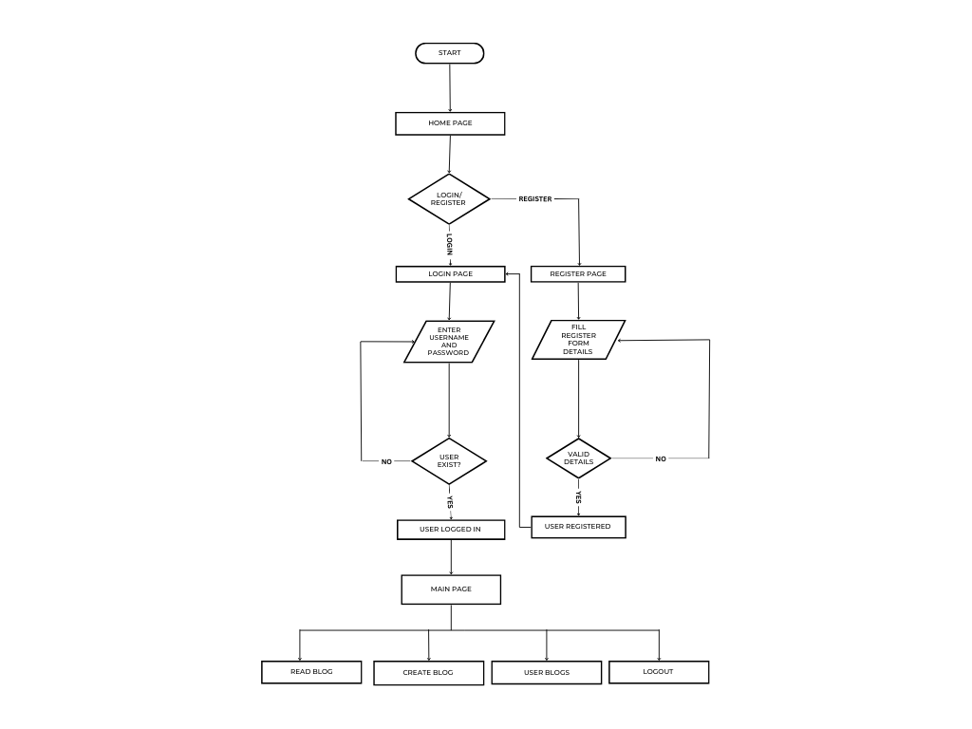

Fig 5.1 Flow Chart of Working System

The flowchart depicts a user journey for a blog website, starting at the home page, where users can choose to login or register. If logging in, users are directed to a login page to enter their credentials, which the system checks against the database. Successful authentication redirects them to the main page. For registration, users fill out a form on the registration page. The system validates these details, creating a new user account upon successful validation and redirecting them to the main page. The main page provides options to read existing blogs, create new ones, view the user's blogs, or log out. Front-end components include HTML, CSS, and JavaScript for displaying pages and forms, while back-end components include a database for storing user credentials and blog posts, an authentication system for managing user sessions, and validation logic for ensuring correct input. This design facilitates a seamless user experience for interacting with the blog website.

**6. IMPLEMENTATION**

**6.1 DEVELOPMENT ENVIRONMENT SETUP:**

**6.1.1 TOOLS AND SOFTWARE:**

* Install Python and Django framework.
* Set up a code editor (e.g., Visual Studio Code).

**6.1.2 DATABASE CONFIGURATION:**

* Use SQLite3 as the database.
* Configure the database settings in Django’s settings file.

**6.2 FRONTEND DEVELOPMENT:**

**6.2.1 HTML/CSS/JAVASCRIPT:**

* Create the structure of the web pages using HTML.
* Style the pages using CSS, ensuring a responsive design with media queries.
* Implement interactivity using JavaScript.

**6.2.2 TEMPLATES:**

* Develop Django templates for various views (home page, user dashboard, blog editor, etc)

**6.3 BACKEND DEVELOPMENT:**

**6.3.1 DJANGO MODELS:**

* Define the models for User and Blog entities.
* Create relationships between models (e.g., a user can have multiple blogs).
* Implement database migrations to create tables in SQLite3.

**6.3.2 VIEWS AND CONTROLLERS:**

* Develop Django views to handle HTTP requests and return appropriate responses.
* Implement controllers to process user inputs and interact with the database.

**6.3.3 FORMS AND VALIDATION:**

* Create forms for user registration, login, and blog management.
* Implement validation logic to ensure data integrity (e.g., unique usernames, valid email formats, etc).

**6.4 USER AUTHENTICATION:**

* Use Django’s built-in authentication system.
* Implement user registration, login, and logout functionalities.
* Secure the application with role-based access control to restrict unauthorized actions.

**6.5 BLOG MANAGEMENT:**

**6.5.1 CREATING BLOGS:**

* Develop a form for users to create new blogs.
* Handle form submissions to save blog content to the database.

**6.5.2 EDITING BLOGS:**

* Allow users to edit their existing blogs through a form.
* Update the blog content in the database upon form submission.

**6.5.3 DELETING BLOGS:**

* Implement functionality for users to delete their blogs.
* Remove the corresponding entries from the database.

**6.6 CATEGORIZATION:**

* Organize blogs into categories for easy navigation.

**6.7 TESTING:**

* Ensure that models, views, and forms work as expected.
* Test the interaction between different components of the system.
* Verify that the application functions correctly as a whole.

**6.8 DEPLOYMENT:**

**6.8.1 LOCAL DEPLOYMENT:**

* Run the Django development server locally for initial testing.
* Use python manage.py runserver to start the local server and test the application.

**6.9 PSEUDO CODE**

**6.9.1 PSEUDO CODE FOR REGISTRATION FORM**

Define class RegistrationForm inheriting from UserCreationForm

Define email field as EmailField, required

Define phone_number field as CharField, not required, max_length 10

Define Meta class

Set model to User

Set fields to ('username', 'email', 'phone_number', 'password1', 'password2')

Define method clean_phone_number

Get phone_number from cleaned_data

If phone_number exists

If phone_number is not all digits or length is not 10

Raise ValidationError 'Phone number must be 10 digits long and contain only numbers.'

Return phone_number

Define method save with parameter commit defaulting to True

Call super().save(commit=False) and assign to user

Set user.email to cleaned_data['email']

Set user.phone_number to cleaned_data['phone_number']

If commit is True

Save user

Return user

**6.9.2 PSEUDO CODE FOR BLOGFORM**

Define class BlogForm inheriting from ModelForm

Define Meta class

Set model to Blog

Set fields to ['title', 'content', 'status', 'category']

Set widgets for content field to HiddenInput

Define method _init_ with parameters *args and **kwargs

Call super()._init_(*args, **kwargs)

Customize error messages for fields

Set title field error message for 'required' to 'Please enter a title for your blog.'

Set content field error message for 'required' to 'Blog content cannot be empty.'

Set category field error message for 'required' to 'Please select a category.'

**6.9.3 PSEUDO CODE FOR MODELS**

Import necessary modules:

Import models from django.db

Import User model from django.contrib.auth.models

Define Blog class as a subclass of models.Model:

Define STATUS_CHOICES as a list of tuples:

Each tuple contains a status key and its corresponding display value.

Define CATEGORY_CHOICES as a list of tuples:

Each tuple contains a category key and its corresponding display value.

Define fields for the Blog model:

title: CharField with max_length of 200

status: CharField with max_length of 10

Use STATUS_CHOICES for possible values

Default to 'publish'

category: CharField with max_length of 20

Use CATEGORY_CHOICES for possible values

Default to 'Other'

content: TextField to store blog content

author: ForeignKey referencing User model

Set on_delete behavior to CASCADE

Allow null and blank values

created_at: DateTimeField

Automatically set to the current date and time when a blog is created

updated_at: DateTimeField

Automatically set to the current date and time when a blog is updated

Define _str_ method to return a string representation of the blog:

Return the title of the blog

**6.9.4 PSEUDO CODE FOR VIEW**

Import necessary modules and models:

Import render, redirect, get_object_or_404 from django.shortcuts

Import login, authenticate, logout from django.contrib.auth

Import AuthenticationForm from django.contrib.auth.forms

Import messages from django.contrib

Import RegistrationForm and BlogForm from .forms

Import Blog model from .models

Define home view function:

Return rendered 'home.html' template

Define register view function:

If request method is POST:

Create RegistrationForm instance with request.POST data

If form is valid:

Save form data

Add success message

Redirect to 'login' route

Else:

Add error message

Else:

Create empty RegistrationForm instance

Return rendered 'register.html' template with form context

Define user_login view function:

If request method is POST:

Create AuthenticationForm instance with request.POST data

If form is valid:

Get 'username' and 'password' from form cleaned data

Authenticate user

If user is authenticated:

Log in user

Redirect to 'main_page' route

Else:

Add error message

Else:

Add error message

Create empty AuthenticationForm instance

Return rendered 'login.html' template with form context

Define main_page view function:

Create context dictionary with username from request.user

Return rendered 'main.html' template with context

Define user_logout view function:

Log out user

Redirect to 'home' route

Define create_blog view function:

If request method is POST:

Create BlogForm instance with request.POST data

If form is valid:

Save form as a blog instance with request.user as author

Redirect to 'blog_list' route

Else:

Create empty BlogForm instance

Return rendered 'create_blog.html' template with form context

Define blog_list view function:

Query Blog objects with request.user as author

Return rendered 'blog_list.html' template with blogs context

Define read_blog view function:

Return rendered 'read_blog.html' template

Define edit_blog view function with optional blog_id parameter:

If blog_id is provided:

Get Blog object with id = blog_id or return 404

Else:

Set blog to None

If request method is POST:

Create BlogForm instance with request.POST data and blog instance

If form is valid:

Save form

Redirect to 'blog_list' route

Else:

Create BlogForm instance with blog instance

Return rendered 'edit_blog.html' template with form context

Define delete_blog view function with blog_id parameter:

Get Blog object with id = blog_id or return 404

If request method is POST:

Delete blog

Redirect to 'blog_list' route

Return rendered 'confirm_delete.html' template with blog context

Define main_view view function:

Return rendered 'main.html' template

Define category_blogs view function with category_name parameter:

Query Blog objects with category name matching category_name (case-insensitive)

Return rendered 'category_blogs.html' template with blogs context

Define main_content view function:

Return rendered 'main_content.html' template

**7. TESTING**

**7.1 UNIT TESTING:**

**7.1.1 MODELS:**

* + Test the User and Blog models to ensure they correctly store and retrieve data.
  + Verify that model constraints (e.g., unique usernames, valid email formats) are enforced.

**7.1.2 VIEWS:**

* + Test view functions to ensure they return the correct HTTP responses.
  + Verify that views render the correct templates and pass the appropriate context data.

**7.1.3 FORMS:**

* + Test the registration, login, blog creation, and blog editing forms for proper validation and error handling.
  + Ensure that forms correctly process input data and interact with the models.

**7.2 INTEGRATION TESTING:**

**7.2.1 USER AUTHENTICATION:**

* + Test the complete registration and login process to ensure users can create accounts and log in successfully.
  + Verify that authenticated users can access restricted pages and perform actions like creating, editing, and deleting blogs.

**7.2.2 BLOG MANAGEMENT:**

* + Test the process of creating, editing, and deleting blogs to ensure data is correctly saved and updated in the database.
  + Verify that users can view their own blogs and interact with the platform as expected.

**7.3 SYSTEM TESTING:**

**7.3.1 END-TO-END TESTING:**

* + Test the full user journey from registration to creating and managing blogs.
  + Ensure all features work seamlessly together and the user experience is smooth.

**7.3.2 PERFORMANCE TESTING:**

* + Test the application’s performance under different loads to ensure it can handle multiple users and concurrent operations.

**8. CONCLUSION**

The Blog Zone project successfully establishes a comprehensive platform for reading, creating, editing, and deleting blogs, categorized by interest. By leveraging the Django framework, SQLite3 database, and modern web technologies (HTML, CSS, and JavaScript), it provides a secure, user-friendly, and responsive environment. Throughout the development process, careful attention was given to both frontend and backend aspects, ensuring an intuitive user interface and robust backend logic. Extensive testing, including unit, integration, system, and user acceptance testing, verified functionality and performance. The Blog Zone meets its initial objectives and demonstrates best practices in web development, emphasizing security, scalability, and maintainability. Features like user authentication, blog management, and categorization contribute to a seamless and engaging user experience. Overall, The Blog Zone is a well-architected, efficiently implemented blogging platform, offering a valuable tool for readers and writers in the digital community. The successful deployment and thorough testing highlight its potential as a scalable and user-centric solution for blogging needs, with strong foundations for future enhancements.

**9. FUTURE ENHANCEMENTS**

The Blog Zone project has established a solid foundation as a functional and user-friendly blogging platform. However, there are several potential enhancements that could further improve the system. Firstly, integrating social media sharing features would allow users to share blogs directly to platforms like Facebook, Twitter, and LinkedIn, increasing the reach and engagement of the content. Secondly, implementing a commenting system would enable readers to interact with the authors and other readers, fostering a community around the blogs.

Additionally, incorporating a recommendation engine that suggests blogs based on users' reading history and preferences could enhance the user experience by providing personalized content. Adding support for multimedia content such as images, videos, and audio in blogs would also enrich the platform, making it more dynamic and engaging.

From a technical perspective, migrating the database from SQLite3 to a more robust system like PostgreSQL or MySQL would enhance the platform's scalability and performance, especially as the user base grows. Implementing advanced security features, such as two-factor authentication and data encryption, would further protect user data and enhance trust in the platform.

Finally, developing a mobile application for The Blog Zone would provide users with on-the-go access, ensuring a seamless experience across different devices. These future enhancements would not only add value to the platform but also ensure its continued relevance and appeal in an ever-evolving digital landscape.

**10. REFERENCES**

[1] <http://google.com>

[2] <https://youtube.com/playlist?list=PLCC34OHNcOtr025c1kHSPrnP18YPBNFi&si=xOgelhUQjmiusTG>

[3] <https://youtu.be/sMqDJovFO-Y?si=uo7Z0GvL83aTCYxt>

[4] <https://realpython.com/build-a-blog-from-scratch-django/>

[5] <https://www.geeksforgeeks.org/blogging-platform-using-django/>

**11. APPENDIX**

**11.1 SNAPSHOTS**

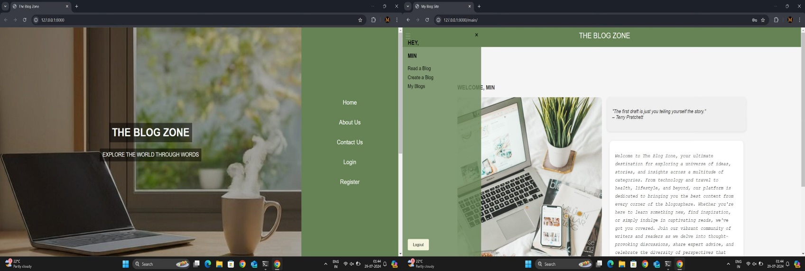

Fig 11.1 Home PageFig 11.2 Main Page

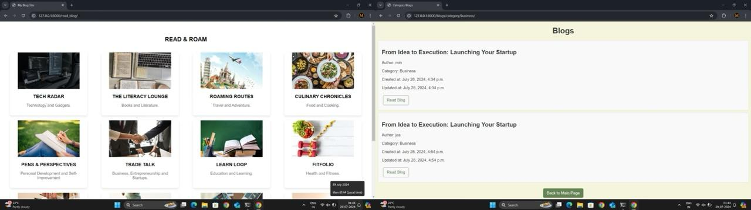

Fig 11.3 Read Blog Page Fig 11.4 Blog Category Page

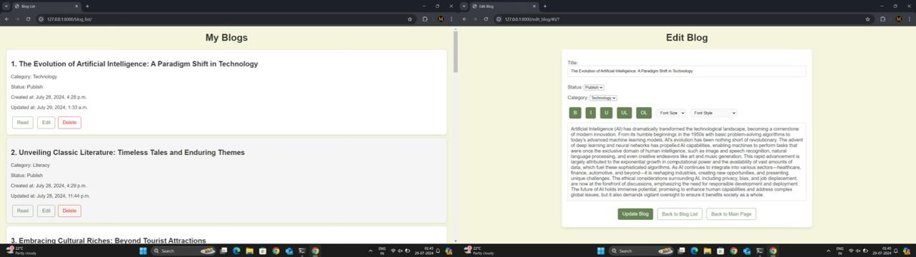

Fig 11.5 Blog List Page Fig 11.6 Edit Blog Page

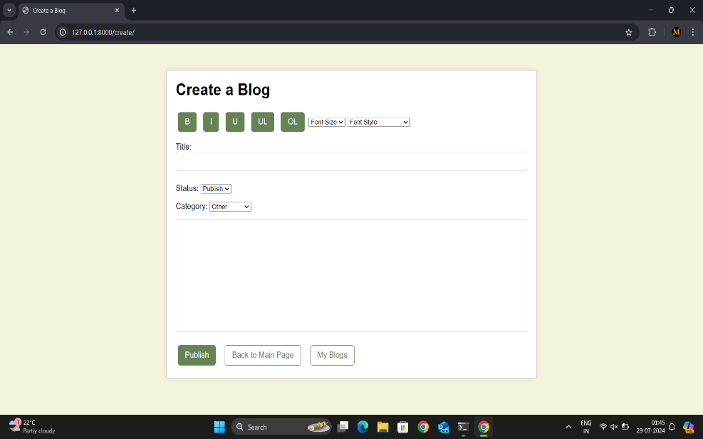

Fig 11.7 Create Blog Page